THE STRUCTURE OF THE EARTH

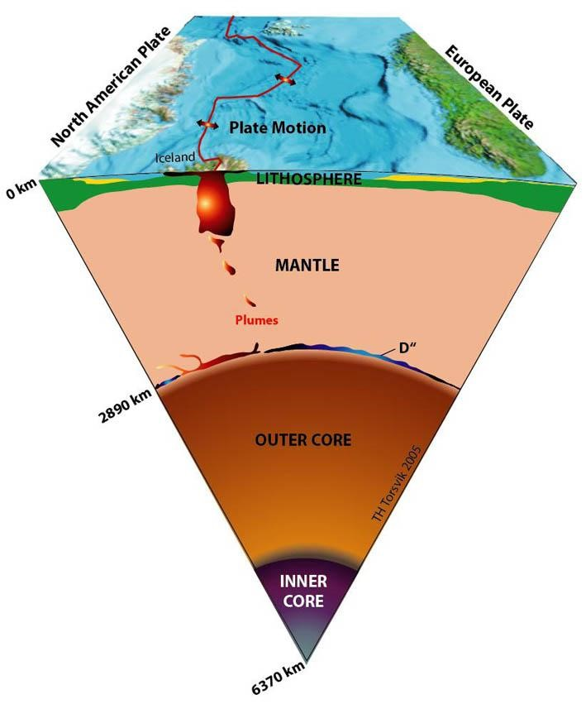

Layer of the Earth | Estimated  Thickness  (kilometres) | State | Estimated  Temperature  (ºC)
Crust | 8 to 64 | Solid and rigid | 20 to 500
Mantle | 2900 | Solid but plasticine - like | 500 to 2000
Outer Core | 2200 | Liquid | 3000
Inner Core | 1300 (radius) | Solid | 4000

www.qldscienceteachers.com
Refer to the information above to answer the questions.
- The crust on which we stand varies in thickness from 8 km to 64 km. Would the crust be thickest under continents (such as Australia and Europe) or under the oceans? Why?
____________________________________________________________________________________________________________________________________
- The continents are situated on crustal plates that can move. What feature of the mantle allows movement of the earth’s crust to occur?
____________________________________________________________________________________________________________________________________
- The table above shows the depths and temperatures recorded in a mine shaft.

Depth (km) | Temperature (ºC)
0 | 20
1 | 51
2 | 82
3 | 112
4 | 142
5 | 171
6 | 201
7 | 230

(a) (i) Plot the data points on the graph paper. Make the bottom axis depth and go from 0km to 20 km. On the vertical axis start at zero and go to 1000⁰C.
(ii) Draw a trend line for the data.
(iii) Extrapolate your trend line (continue beyond your data, best guess) all the way out to the 20 km depth.
(b) Predict the temperature at– 8 km depth _____ and 20 km depth ______.
(c) The deepest mine is less than 10 kilometres deep. How do you think geologists (scientists who study earth movements and rocks) estimate the thickness and temperature of the layers of the earth? Have your best guess!!

www.qldscienceteachers.com

